The Centers for Disease Control and Prevention (CDC) collects extensive raw data pertaining to health and chronic diseases. While the data may not initially appear to exhibit discernible patterns, data science enables the identification of these patterns and correlations, thereby enhancing our comprehension of the data.
One pertinent question arises: does location serve as a robust indicator of health issues? Are there significant correlations between demographics and health concerns? By analyzing specific topics, could we discern distinct clustering among groups, suggesting that demographics exhibit substantial differences? Alternatively, would we observe weak relationships, indicating that models encounter challenges in identifying patterns or that the relationships do not exist?
I embarked on this project with an open mind, eager to uncover these relationships. Utilizing the acquired skills from the course and my major, I was able to identify significant relationships. By discerning strong versus weak relationships, we can enhance patient care and develop policies aimed at improving health nationwide.
The data utilized in this project was sourced from the CDC, a reputable government resource that ensures unbiasedness.
The data itself comprises approximately 300,000 rows related to health. Each row includes a unique State identifier, which corresponds to one of the 50 states in the United States. Stratification1 provides demographic information, such as Gender, Race, or Age. Additionally, there is a Year column that covers the years 2015 to 2020. For each combination of Stratification1/State and Year, there are various Questions, such as “Coronary heart disease mortality among all people, underlying cause” or “Binge drinking frequency among adults who binge drink.” Although I delayed using pivot tables until the end, they proved to be helpful in effectively combining the Stratification1/State rows for each Question.
I began my EDA by reading the CSV into pandas and comparing the number of locations and topics. Cardiovascular and pulmonary issues were the highest chronic disease topics, but I knew that alcoholism and mental health were more intertwined and was pleased to see there was a health amount of data related to those topics.
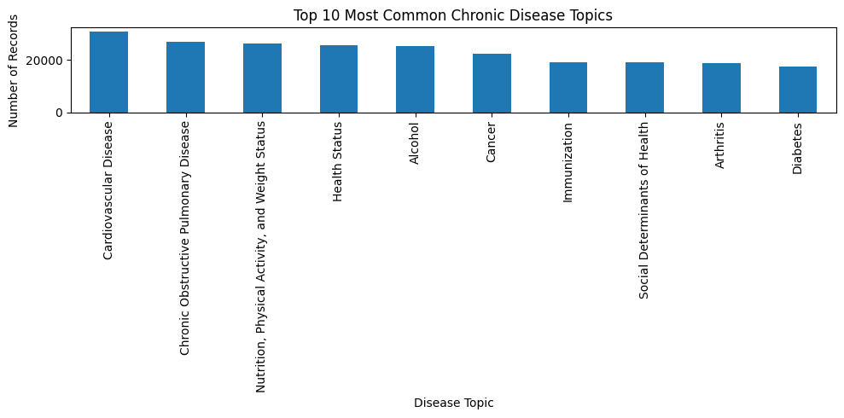
I was also aware that there would be variations among different demographics, which could aid in predicting values or clustering later on. At this stage, I hypothesized that we would establish clusters centered around the categories and attempt to predict which row would belong to its respective cluster. For instance, I found that Whites generally had higher alcohol consumption compared to Blacks. If we had only two clusters, it might be possible to successfully match a row to the appropriate cluster.
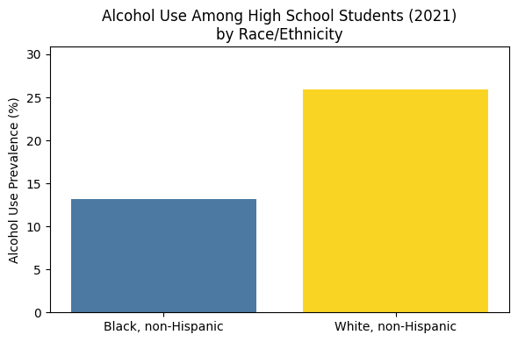
Predicting for states was challenging due to limited data (only 5 years per state). States lack context, so I created regions (South, Northeast, Northwest, West) based on location. My goal was to assess location’s clustering strength (e.g., depression in the Northeast, drinking in the South). I also limited my search for demographics that higher response rates. For example, there was more data from 45–64-year-olds vs 0 to 40 year olds. There were also cases of low response rates from certain demographics, such as Native Americans, which could’ve skewed their results. I created unique data frames for each unique demographic (again, these were Gender, Age, and Race) and set out to train and evaluate models.
My first type of model was unsupervised learning known as clustering. I chose the question “Binge drinking frequency among adults who binge drink”. I initially tried to use K-Means, but there wasn’t enough numerical data to achieve optimal results. Instead, I tried something I’d never used before: K-Mode clustering. When I tried to match the rows with clusters, I saw the accuracy was mostly consistent with the Silo score. The White Non-Hispanic demographic, for example, had a Silo score of 72, and 3 of the 4 rows were matched to the correct location. I would’ve preferred to use K-Means, but the K-Means showed very poor clustering points, indicating that states within a region do not cluster and have strong clustering relationships. Therefore, we can conclude that states do not match their region as it relates to binge drinking (given the low parity of the Euclidean distance).
In an attempt to improve the accuracy of the training model, I implemented a second model utilizing the Random Forest Classifier. The racial data frames were combined, and the labels were encoded. The objective of this model was to predict the race or ethnicity of a row based on its data value. The model achieved an accuracy of 41%, indicating a lack of effectiveness. Consequently, we can conclude that there is no significant difference in the response among different ethnicities. It is possible that for other topics, there would be notable differences, resulting in a model that successfully classifies a row to the correct ethnicity. However, for this specific topic, the model’s performance was unsatisfactory.
Thus far we had proven that states are not beholden to their regions when it comes to binge drinking and ethnicities were not different from each other when it came to mental health days. The poor performance wasn’t an indication that we had failed, it more so proved that the relationships were weak or nonexistent.
In a bid to identify a viable solution, I employed the largest age group (45-64) and constructed a pivot table for the remaining mental health and alcohol-related inquiries. This time, we opted for linear regression as our model and achieved an R^2 score of 81%. This was our most accurate result, and it also revealed the most significant features, namely that “Average mentally unhealthy days among adults” and binge drinking played a substantial role in “Routine checkup within the past year among adults.”
There are several results to draw from the project. Clustering, classification and regression were utilized to explore relationships, but their successes/failures were likely the result of poor relationships. For example, attempting to classify ethnicities yielded poor results, but that was because the question of mental health didn’t show stark patterns among different ethnic groups. It’s also possible that if we controlled for fewer groups, we could’ve achieved more accurate results. Pivot tables were utilized at the last step, but if we had pivoted the data to compare multiple numerical features, we likely would’ve found more relationships. I cannot stress enough how changing the target could lead to strong correlations. It was also relevant to compare different demographics. For example, our linear regression showed a strong correlation in the 45-64 group, but that correlation wasn’t guaranteed to be present in all age groups.
The impacts of this project are quite powerful. Based on our models, it is unlikely that a datapoint’s region plays a significant role in a state’s rate of Binge Drinking. Across ethnic groups, there isn’t enough variance to properly classify mental health issues. However, for 45–64-year-olds, there is a strong correlation between mental illness and annual physicals. We could recommend annual physicals for those ages 45-64, especially if they are suffering from mental illness. Further work could explore more complex patterns for both features and demographics.

